**1. Browsing the product card.. User access with employee rights via the API. ID:100**

Description:

Each user with employee rights does not have access to view product cards according to the requirements.

Severity:Critical Priority:High

Steps to reproduce:

1. Open Postman
2. Send get request of the type see attachment 1
3. Click the "Save" button”.
4. Check the result with the “Send " button”.

Actual result: Server response code: 200 OK.

Expected result: Server response code: Error 403 access denied.

Environment:

https://radio-shop.megaplan.by/admin/offer/list

Employee with common rights:

User***/user***

Attachments:

Attach. 1 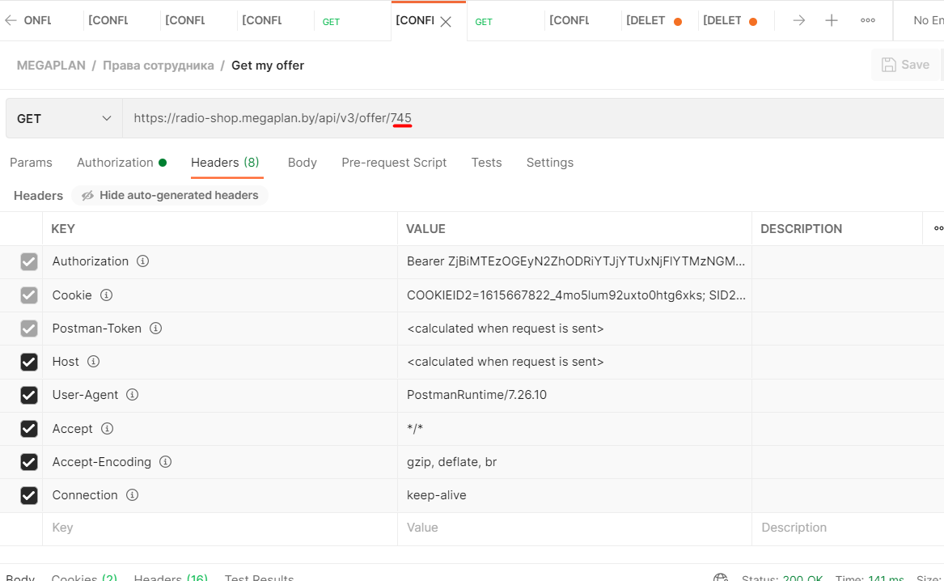

Attach. 2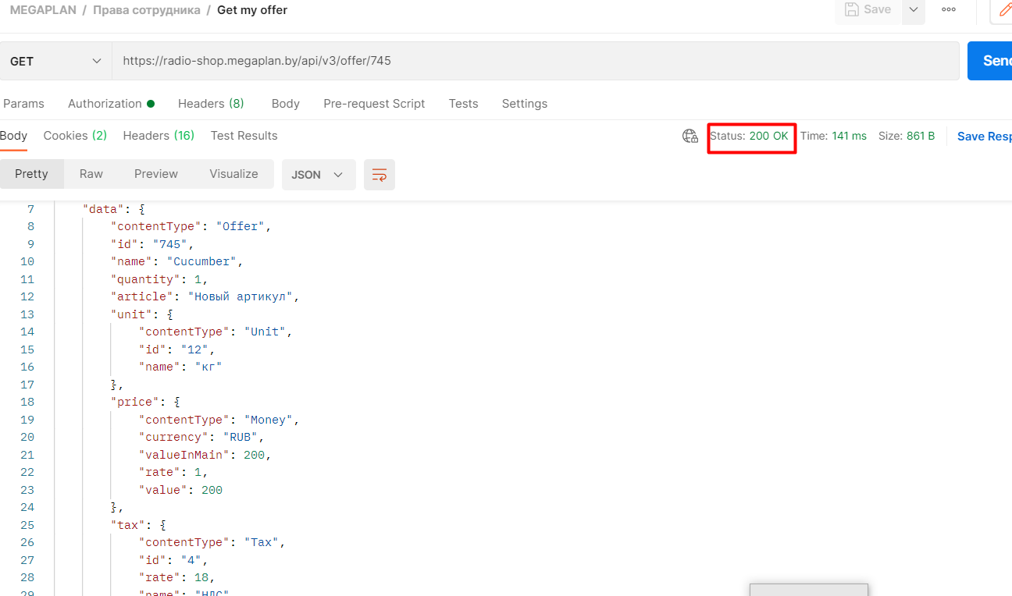

**2. Deleting the product card. User access with employee rights via the API. ID:101**

Description:

Each user with employee rights does not have access to delete product cards according to the requirements. Priority:High Severity:Critical

Steps to reproduce:

1. Open Postman
2. Send Delete request of the type see attachment 3
3. Click the "Save" button”.
4. Check the result with the “Send " button”.

Actual result: Server response code: 200 OK.

Expected result: Server response code: Error 403 access denied.

Environment:

https://radio-shop.megaplan.by/admin/offer/list

Employee with common rights:

User***/user***

Attachments:

Attach.3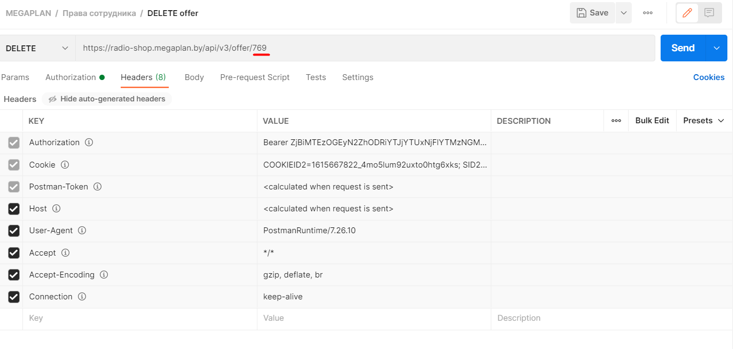

Attach.4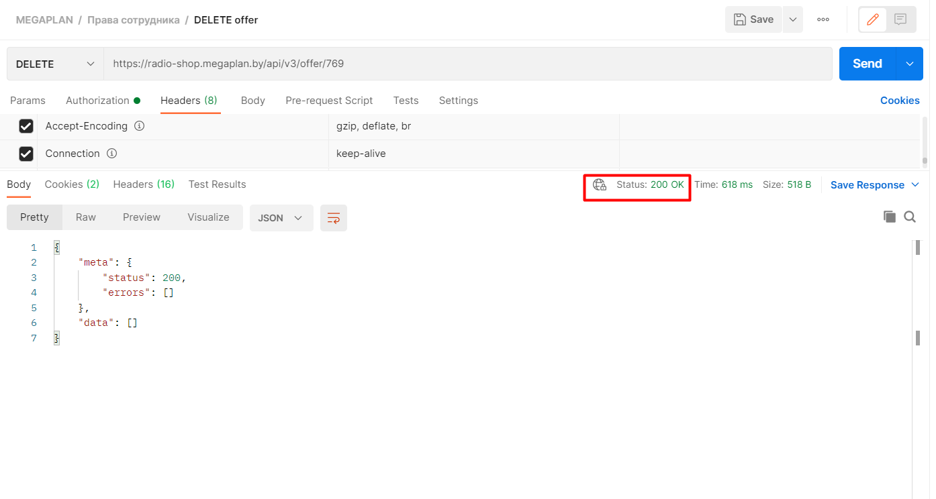

**3. Form. Field ”How did you find out about us” is not required to be filled in. ID:102**

Description: The input data of the ”How did you find out about us " field is not sent to the server.

Severity:Critical Priority:High

Steps to reproduce:

1. Open the form.
2. Fill in all the form fields with valid data.
3. Field “How did you find out about us " leave empty.
4. Click the "Submit" button.
5. Check the result.

Actual Result: The field with an asterisk ”How did you find out about us” is optional.

Expected Result: The field with an asterisk ”How did you find out about us” is mandatory.

Attachments:

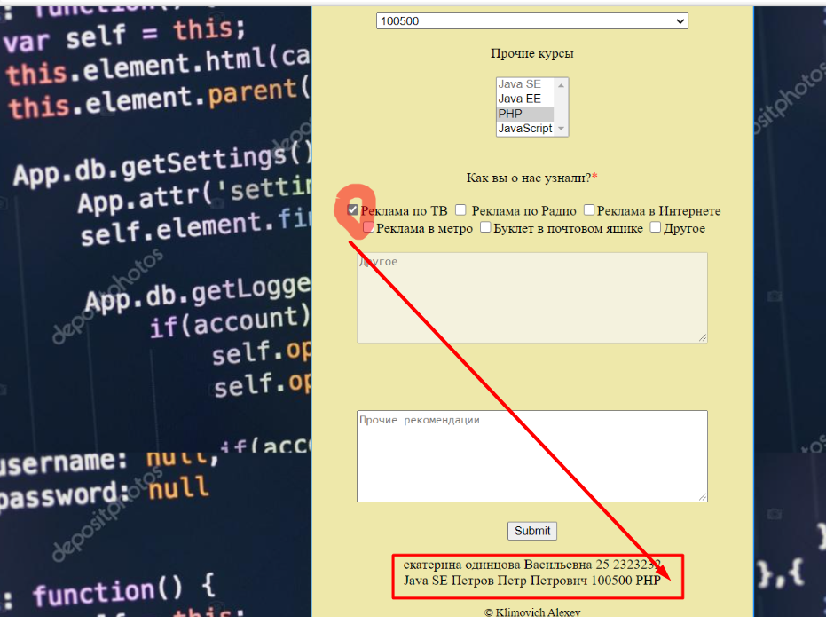

**4.Form. Field “Age”. There is no limit on the number of characters in the field. ID:103**

Description:

Severity: Major Priority: High

Steps to reproduce:

1. Open the form.
2. Fill in the the “Age” field number 290193485738.
3. Fill in the rest fields with valid data.
4. Click the "Submit" button.
5. Check the result.

Actual Result: An unlimited number of digits are entered in the " Age " field.

Expected Result: An error is displayed in the " Age " field. A limited number of digits are entered (Clarification is required).

Attachments:

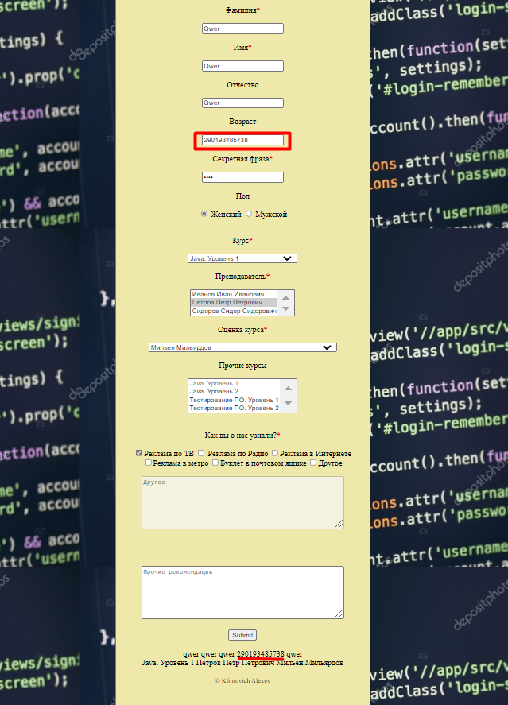

**5.Cart. Product that you are trying to add is not available. ID:104**

Description: Mismatch in the quantity of the declared product.

Severity: Major Priority: High

Steps to reproduce:

1. Open <https://qatest-dev.indvp.com/product/alvarado-tray>
2. Add the product to the basket.
3. Check the result.

Actual Result: The product isn’t added to the shopping cart.

Expected Result: The product is added to the shopping cart.

Attachments:

